|  |  |  |  |  |
| --- | --- | --- | --- | --- |
| Revision | DOC# | Description | Approved | Date |
| 01 | TBD | Initial released |  |  |

**Crosby ToF Module**

**Engineering Requirement Specification**

**Table of Contents**

1. **Change History**
2. **Document Description**
3. **Functional Specifications**  
   2.1   
   2.1.1  
   2.1.2  
   2.2  
   2.3
4. **Mechanical Specifications**  
   3.1  
   3.1.1  
   3.1.2  
   3.2  
   3.3
5. **Process Specifications**  
   4.1  
   4.1.1  
   4.1.2  
   4.2  
   4.3
6. **Operational Specifications**  
   5.1  
   5.1.1  
   5.1.2  
   5.2  
   5.3
7. **Reporting Requirements**  
   6.1  
   6.1.1  
   6.1.2  
   6.2  
   6.3
8. **Measurement Methods**  
   7.1  
   7.1.1  
   7.1.2  
   7.2  
   7.3
9. **Projector Metric Deﬁnitions**  
   9.1   
   9.1.1  
   9.1.2  
   9.2

**APPENDIX A**

**APPENDIX B**

1. **Change History**

|  |  |  |  |
| --- | --- | --- | --- |
| **Version** | **Description** | **Date** | **Editor** |
| 0.1 | Updated process specification | 10/19/21 | Paul O’Sullivan |
|  |  |  |  |

1. **Document Description**

This Document describes the ADI Crosby TOF camera module. This camera module includes the following key features:

* TOF Sensor (1024x1024 resolution), 3.5x3.5um pixels
* IR Lens w/ Fixed focus, 940±10nm, 1G4P, M8.5xP0.25, 75.2˚(H)x75.2˚(V)x105.8˚(D), F/#1.2, TTL 11.57 mm @ inf. Distance
* VCSEL with central wavelength 940nm (305 emitters)
* Diffuser - Refraction type w/ collimating lens, 940±10nm, 1P, 80˚(H)x80˚(V), cos-1-cos-4(H&V), TTL 11.77mm
* I2C control interface
* MIPI 2 lane

**Specification Confidentiality**

The Contents of this Engineering Requirements Specification, including All Drawings & Tables & Images are LGIT confidential information subject to the non-disclosure and use restrictions set forth in the confidentiality Agreement between the LGIT and Customer.

Other Confidential Contents ADD

1. **Functional Specification**
   1. Module Requirements
   2. FOV / FOI Reference
   3. Module Performance Requirements  
      All items must be performed as 100% production tests with the limits provided below unless otherwise noted.  
      **Module Performance Requirements TABLE DATA**

|  |  |  |  |  |  |
| --- | --- | --- | --- | --- | --- |
| Condition | Test item | Remarks | Data | Unit | Notes |
| VCSEL chip  LIV3.3.3)  (305e, 10μm) | Icon | Current condition |  | A | 20 ns on/off pulse condition |
| WL | Central wavelength |  | nm | 50℃ |
| Ptot | Total optical power |  | W | 50℃ |
| Vf | Voltage |  | V | 50℃ |
| Ith | Threshold current |  | A | 50℃ |
| SE | Slope efficiency |  | % | Ptot/(Icon-Ith) |
| PCE | Power conversion efficiency |  | % | Ptot/(Vf x Icon) |
| Rf | Series resistance |  | Ω | (Vf-Vth)/Icon |
| Tx mo Tx module  using doogwoon DRV IC  (@ 60 MHz)dule  using doogwoon DRV IC  (@ 60 MHz) | Iavg | Average current |  | A | Average current @ 50 MHz |
| Ipeak | Peak current |  | A | Iavg/DC |
| Ppeak_wo_diff | Peak optical module power |  | W | OOP_wo_diff /DC |
| Ppeak_w_diff_Himax | Peak optical module power |  | W | OOP_w_diff_Himax /DC |
| Ppeak_w_diff_LGIT | Peak optical module power |  | W | OOP_w_diff_LGIT /DC |
| OOP_wo_diff | On-time optical power (OOP) without diffuser |  | W | Newport power meter w/o diffuser @ 250 kHz3.3.6) |
| OOP_w_diff_Himax | OOP with Himax diffuser |  | W | Newport power meter w diffuser @ 250 kHz |
| OOP_w_diff_LGIT | OOP with LGIT diffuser |  | W | Newport power meter w diffuser @ 250 kHz |
| T_diff_Himax | Transmittance of Himax diffuser |  | % | OOP_w_diff_Himax / OOP_wo_diff |
| T_diff_LGIT | Transmittance of LGIT diffuser |  | % | OOP_w_diff_LGIT / OOP_wo_diff |
| DC | Duty cycle of pulse |  | % | 5 GHz PD @ 4 GHz OSC3.3.7) |

*Iavg and OOP should be measured on the direct board.3.3.9)

3.3.3 VCSEL LIV measurement condition

3.3.4 VCSEL Figure of merit vs OOP

3.3.6 Module power reference setup to measure the OOP and AOP

Newport Power meter (model 1936-R)

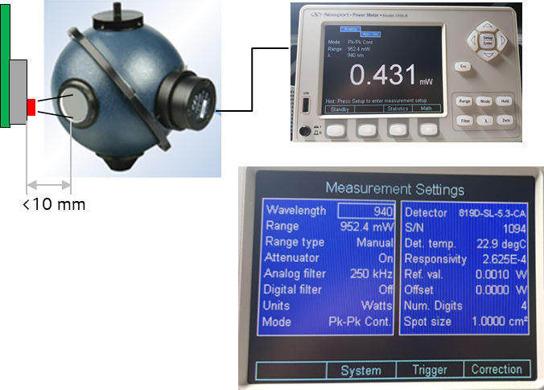

* OOP(On-time Optical Power) : Analog filter setting 250 kHz (reference to exposure time)
* AOP(Average time Optical Power): Analog filter setting 5 Hz (reference to fps)

3.3.7 Tx pulse reference setup to measure the duty cycle

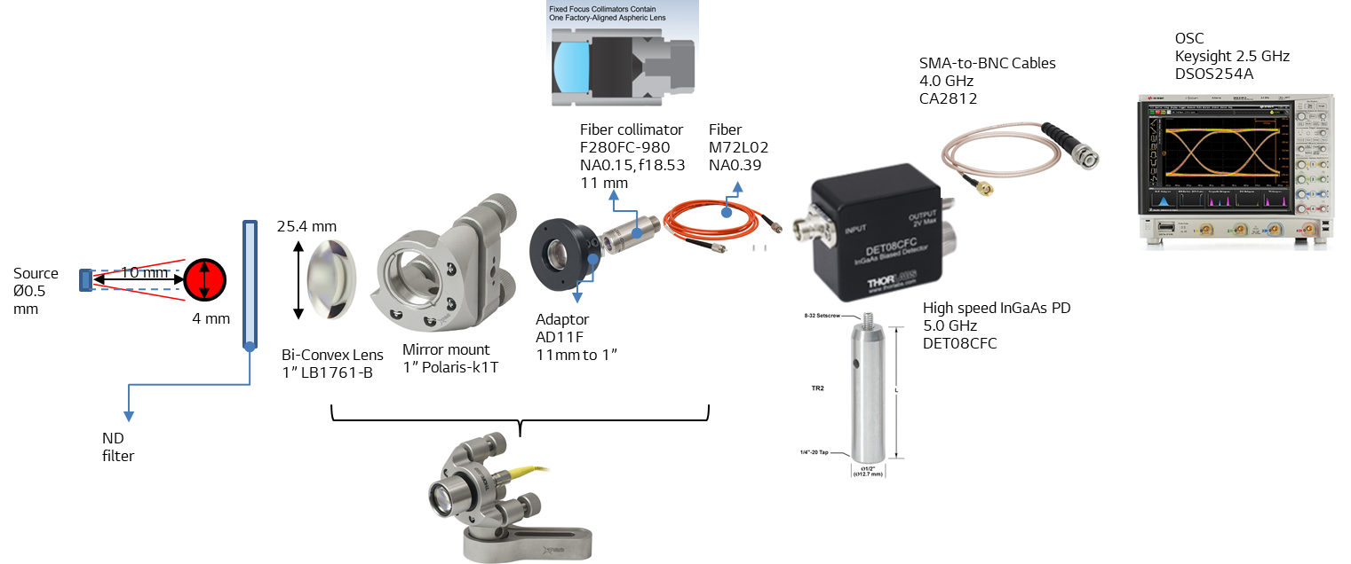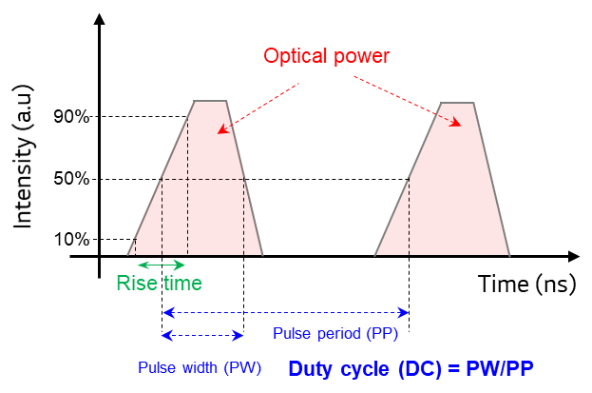

3.3.8 Pulse, Phase, and Frame

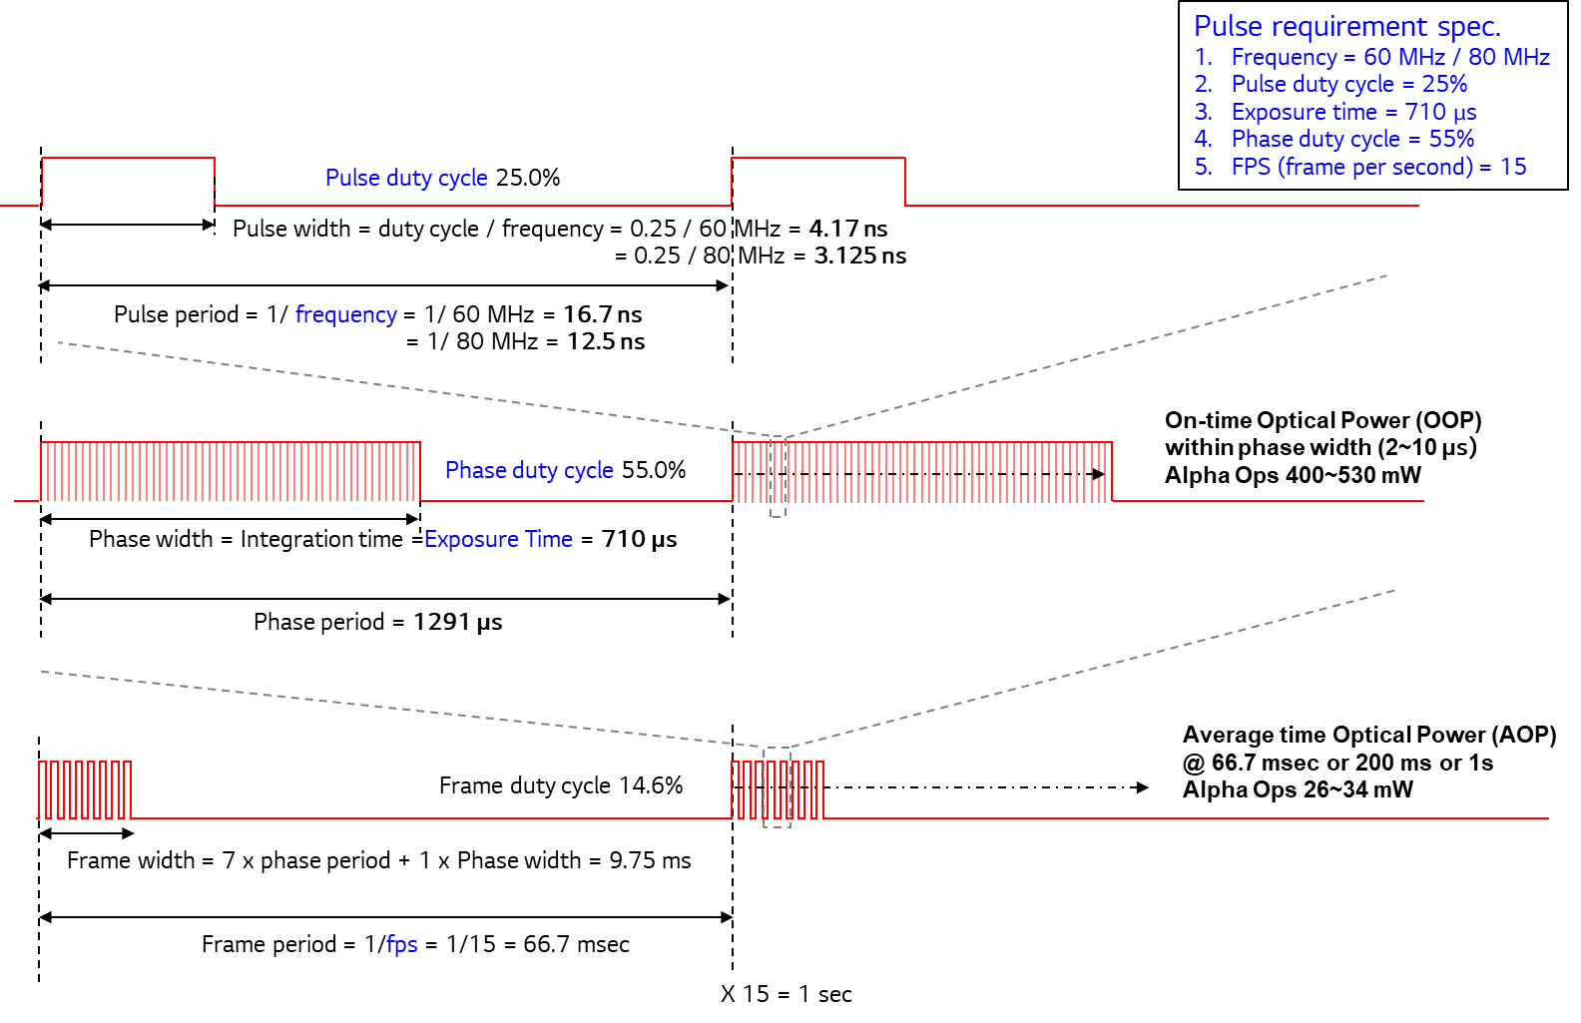

* 1. Electrical Specifications
     1. Clocks
     2. TOF Sensor Die Pads and Dimensions
     3. VCSEL Die Pads and Dimensions.
     4. Module Cube Pinout
     5. Module Assembly Pinout
  2. Optical Specifications
     1. Tx Diffuser

|  |  |  |
| --- | --- | --- |
| **Diffuser** | | |
| **Item** | | **D105** |
| Mechanical | Type | Refraction + MLA |
| MLA Size | 300 um |
| Diffuser Size [mm] | 8.5 x 8.5 |
| MLA Effective Area [mm] | 7.5 x 7.5 |
| Optical | FOI X | 80 deg |
| FOI Y | 80 deg |
| Optical efficiency within |  |
| H and V energy drop off outside FOI |  |
| Illumination Profile |  |
| Uniformity |  |
| Material | APEL |
| Eye Safety | Apparent Source Size | 5 mm |
| Max PER |  |
| Eye Aperture Factor | C6 = 33.3 |
| VCSEL Max Optical Power | 8 W |
| Exposure Time | 250 us |

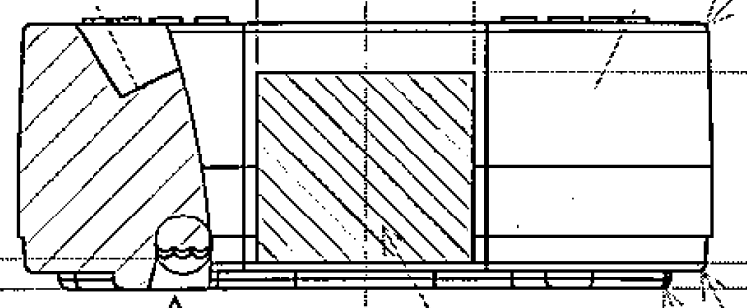

LGIT update

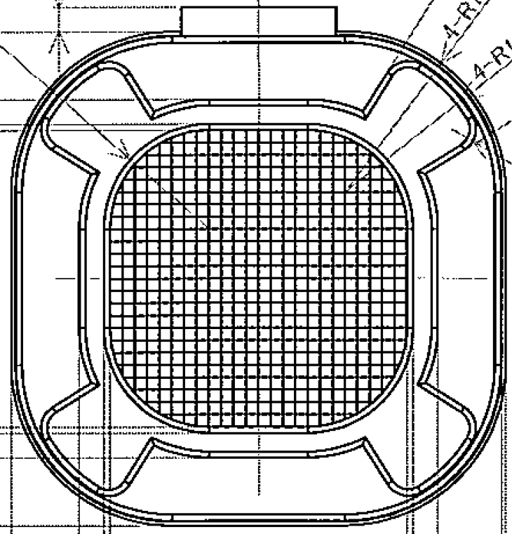 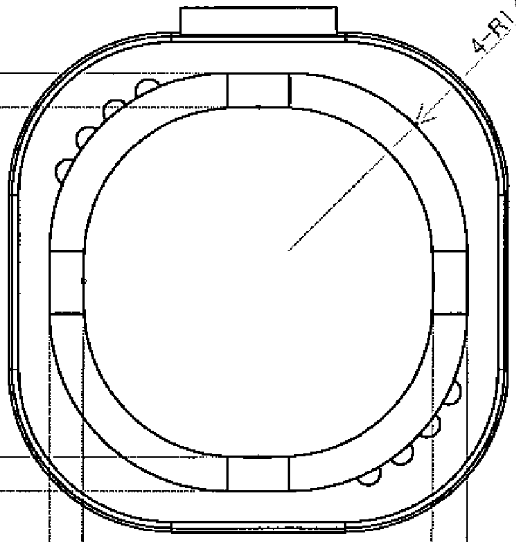**<Diffuser Layout>**

LGIT update

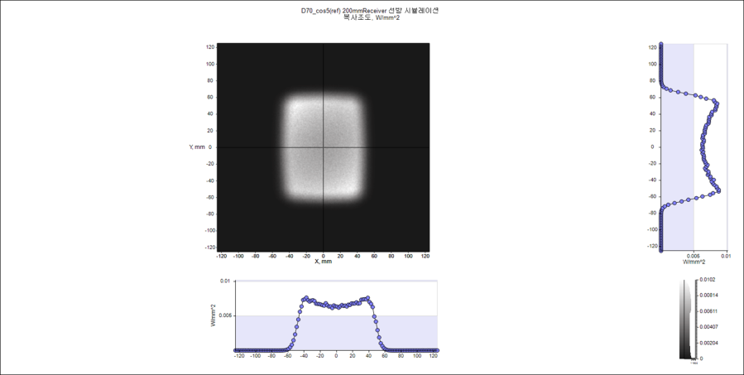

**<Irradiance Distribution> <Intensity Profile>**

* + 1. Rx Lens

|  |  |  |
| --- | --- | --- |
| **Item** | **Specification Point** | **D106** |
|
| Module Feature | sensor size / format | 3.584 x 3.584 / 1.36 “ |
| Pixel size | 3.5 um |
| Effective Focal Length  (EFL) | Design value (at 940nm) | 2.74 |
| Design value (Convert into 35mm ) | 23.6 |
| F-number | Image space F/# | 1.2 |
| Field of View | Vertical FOV (degrees) | 75.2 |
| Horizontal FOV (degrees) | 75.2 |
| Diagonal FOV (degrees) | 105.8 |
| Image Circle | Effective (mm) | 5.0685 |
| Max (mm) | 5.3 |
| MTF | at object distance | 750 mm |
| 0% field of view MTF @ ½ Ny freq | 88.0% |
| 30% field of view MTF @ ½ Ny freq | 84.7% (S); 83.9% (T) |
| 60% field of view MTF @ ½ Ny freq | 72.5% (S); 85.8% (T) |
| 80% field of view MTF @ ½ Ny freq | 72.0% (S); 82.4% (T) |
| 90% field of view MTF @ ½ Ny freq | 71.2% (S); 82.2% (T) |
| Distortion | Optical Distortion (F-Tan) | < 30.1% |
| Optical Distortion (F-Theta) | < 1.0% |
| Relative Illuminance | at Image Diagonal (FOV) | 70.0% |
| at Max Image Circle (Max image circle) | 67.2% |
| Chief Ray Angle | Deviation between sensor and optics | Lens CRA 16.4 deg  Sensor CRA 17 deg |
| Back Focal Length (BFL) | From apex of rear surface (mm) ±0.05mm | 3.885 |
| Flange Back Length (FBL) | From flange of rear element (mm) ±0.05mm | 3.42 |
| Total Track Length (TTL) | Sensor(image plane) to Lens top (mm) ±0.05mm | 11.528 |
| Construction | Lens construction / Stop position | 1G4P/ stop between 2nd and 3rd element |

* + 1. IR Pass Filter

|  |  |  |
| --- | --- | --- |
| **No.** | **Optical Specification** | |
| **Item** | **Thickness=0.21mm** |
| 1 | IR BPF | 940nm |
| 2 | 350-895nm | Ave OD≧4; Abs OD≧4 |
| 4 | 933-947nm (AOI = ) | Tave≧95%; Tabs≧90% |
|  | 924.5-950nm (AOI = ) | Tave≧95%; Tabs≧90% |
| 5 | 1005~1100nm | Ave OD≧4; Abs OD≧4 |
| 6 | T10% Bandwidth | ≦48.5nm (AOI = )  ≦51.5nm (AOI = ) |
| 7 | T90% CWL Shift AOI=0º to 30º | ≦10.5nm |

* 1. **Module Test and Calibration Requirements**

Each module needs to go through the below test and calibration steps. All stations including and after optical power calibration require active illumination.

|  |  |  |  |
| --- | --- | --- | --- |
| name | Station name | Tact time  (Target, seconds_ | Station  multiplicity |
| Focus | EE IQC |  | Focus |
| Gain calibration |  |
| Focus SFR |  |
| barrel lock  and dispensing |  |
| Geometric | Geometric calibration |  | Geometric |
| Light box | Blemishes,  Relative illumination |  | Light box |
| Optical power | Optical power |  | Laser power |
| EE power |  |
| Depth Cal | Po |  | Depth calibration |
| FOI | Hot spot |  | FOI |
| FOI |  |
| FOI data processing |  |
| Depth performance | Performance capture |  | Depth performance |
| DPS data processing |  |

* + 1. **Focus**
       1. **EE IQC**

The module should be checked to ensure it is electrically functional before going through the calibration pipeline. The frame grabber has measurement circuitry to perform basic electrical tests on power supply voltages, clock/PLL frequencies, and to verify MIPI streaming from the image sensor. There no need for additional equipment and the incoming quality check can be performed before calibration or at the first calibration station.

The ADI frame grabber has power monitors to measure the voltage and current on each of the module power rails. It can also be used to send commands to configure the ADSD3100 to output internal signals on analog test pins (ATP and ATN) so that they can be measured on the frame grabber to verify correct operation. Note, the incoming quality checks should be performed without active illumination for eye safety reasons, since optical power calibration has not been performed on the module yet. Later in the calibration pipeline after the optical power calibration has been performed, the supply rails can be monitored in normal operation to verify power supply rails are behaving as expected.

After verifying that all voltages and currents are within limits, the ADSD3100 module is programmed to operate in passive mode which triggers the capture of IR images. The frame grabber acquires few frames through the MIPI interface to validate the ADSD3100 imager operation. This test verifies the streamed video data quality.

|  |  |  |  |  |
| --- | --- | --- | --- | --- |
|  | **Value** | **Pass/Fail** | **Min** | **Max** |
| Vmain_pre_V | 4.234 | PASSED | 3 | 5 |
| Imain_pre_mA | 0.3 | PASSED | -1 | 200 |
| Vsys_pre_V | 0 | PASSED | -1 | 0.5 |
| Isys_pre_mA | 0 | PASSED | -1 | 1 |
| Vdepth_pre_V | 0 | PASSED | -1 | 0.5 |
| Idepth_pre_mA | 0 | PASSED | -1 | 1 |
| Vaux_pre_V | 0.344 | PASSED | -1 | 1 |
| Iaux_pre_mA | 0 | PASSED | -1 | 1 |
| Vmain_static_V | 4.235 | PASSED | 3 | 5 |
| Imain_static_mA | 0.3 | PASSED | -1 | 200 |
| Vsys_static_V | 4.235 | PASSED | 3 | 5 |
| Isys_static_mA | 3.8 | PASSED | -1 | 50 |
| Vdepth_static_V | 5.338 | PASSED | 4 | 6 |
| Idepth_static_mA | 0.1 | PASSED | -1 | 50 |
| Vaux_static_V | 18.027 | PASSED | 17 | 19 |
| Iaux_static_mA | 0.5 | PASSED | -1 | 50 |
| Vmain-on_V | 4.234 | PASSED | 3 | 5 |
| Imain-on_mA | 27 | PASSED | -1 | 200 |
| Vsys-on_V | 4.235 | PASSED | 3 | 5 |
| Isys-on_mA | 2.1 | PASSED | -1 | 50 |
| Vdepth-on_V | 5.338 | PASSED | 4 | 6 |
| Idepth-on_mA | 0.3 | PASSED | -1 | 50 |
| Vaux-on_V | 18.043 | PASSED | 17 | 19 |
| Iaux-on_mA | 0.3 | PASSED | -1 | 50 |
| VDDA1_V | 1.261375 | PASSED | 1.24 | 1.3 |
| VHIGH_V | 3.341375 | PASSED | 3.25 | 3.45 |
| VLOW_V | 1.012125 | PASSED | 0.9 | 1.1 |
| VLD_V | 0 | NA | -0.1 | 0.1 |
| Photodetector check |  | TBD | TBD | TBD |

* + - 1. **Gain & Offset**

The gain and offset of amplifiers and column ADCs, internal to the sensor, are calibrated to remove column fixed pattern noise in the captures and to ensure that the largest measurement range can be achieved across the image sensor without saturating the column ADCs.

The gain and offset calibration does not require a dedicated calibration station or any dedicated hardware (other than the frame grabber that control the camera and captures frames).

|  |  |  |  |  |
| --- | --- | --- | --- | --- |
|  | **Value** | **Pass/Fail** | **Min** | **Max** |
| adc_iramp | 189.176 | No Limit |  |  |
| adc_delay | 52.2 | PASSED | 50 | 55 |
| adc_up_dn_delay | 414 | No Limit |  |  |
| Gain0_MeasNative | 14.509 | PASSED | 14.4 | None |
| Gain1_MeasNative | 6.749 | PASSED | 6.6 | None |
| Gain2_MeasNative | 2.323 | PASSED | 2.2 | None |
| Gain3_MeasNative | 0.716 | PASSED | 0.6 | None |
| GainCal_0_ADC_min | 18 | PASSED | 4 | 100 |
| GainCal_0_ADC_mean_low | 36.023 | No Limit |  |  |
| GainCal_0_ADC_mean_high | 465.975 | No Limit |  |  |
| GainCal_0_ADC_max | 483 | PASSED | 410 | 510 |
| GainCal_1_ADC_min | 16 | PASSED | 4 | 100 |
| GainCal_1_ADC_mean_low | 32.636 | No Limit |  |  |
| GainCal_1_ADC_mean_high | 466.963 | No Limit |  |  |
| GainCal_1_ADC_max | 480 | PASSED | 410 | 510 |
| GainCal_2_ADC_min | 21 | PASSED | 4 | 100 |
| GainCal_2_ADC_mean_low | 35.91 | No Limit |  |  |
| GainCal_2_ADC_mean_high | 490.017 | No Limit |  |  |
| GainCal_2_ADC_max | 502 | PASSED | 410 | 510 |
| GainCal_3_ADC_min | 180 | No Limit |  |  |
| GainCal_3_ADC_mean_low | 193.403 | No Limit |  |  |
| GainCal_3_ADC_mean_high | 333.291 | No Limit |  |  |
| GainCal_3_ADC_max | 345 | No Limit |  |  |
| Vref1DAC | 7 | No Limit |  |  |
| Vref2DAC | 5 | No Limit |  |  |
| Vref3DAC | 15 | No Limit |  |  |
| voltage_comp_vref1 | 38.25 | PASSED | 33 | None |
| voltage_comp_vref2 | 77.75 | PASSED | 68 | None |
| voltage_comp_vref3 | 335.375 | PASSED | 295 | None |
| VCMDAC | NaN | No Limit |  |  |
| inverseGlobalADCGain_0 | 6656 | No Limit |  |  |
| inverseGlobalADCGain_1 | 5670 | No Limit |  |  |
| inverseGlobalADCGain_2 | 4895 | No Limit |  |  |
| inverseGlobalADCGain_3 | 2696 | No Limit |  |  |

* + - 1. **VLow**

The ADSD3100 internal VLOW step-down regulator should be tested and adjusted to operate within the datasheet limits. VLOW can be measured though the analog test interface (pins ATP and ATN).

|  |  |  |  |  |
| --- | --- | --- | --- | --- |
|  | **Value** | **Pass/Fail** | **Min** | **Max** |
| vlow_lin | 1.00263 | PASSED | 0.95 | 1.05 |
| vlow_sw | 0.9975 | PASSED | 0.95 | 1.05 |
| DAC_SatRef | 0.74838 | No Limit |  |  |
| DAC_TX1 | 1.10338 | No Limit |  |  |
| DAC_Bias1 | 0.25313 | No Limit |  |  |
| DAC_Bias2 | 1.09913 | No Limit |  |  |
| DAC_Vrest | 0.499 | No Limit |  |  |
| vlow_vadj | 2569 | No Limit |  |  |
| DAC_SatRef_val | 71 | No Limit |  |  |
| DAC_TX1_val | 137 | No Limit |  |  |
| DAC_Bias1_val | 31 | No Limit |  |  |
| DAC_Bias2_val | 136 | No Limit |  |  |
| DAC_Vrest_val | 118 | No Limit |  |  |

* + - 1. **Focus**

The imaging lens is rotated in the lens barrel until the desired focus level is achieved. The focus test is performed with a dedicated focus chart and software that measures the modulation transfer function (MTF) at different locations on the focus chart. Passive IR illumination is used to illuminate the chart and the camera captures 2D IR images in passive mode to be used for the focus adjustment. For Crosby, the lens is focused at a chart to lens distance of 700mm

|  |  |  |  |  |
| --- | --- | --- | --- | --- |
|  | **Value** | **Pass/Fail** | **Min** | **Max** |
| MTF50Center | 0.1219 | PASSED | 0.1 | None |
| MTF30Center | 0.2026 | PASSED | 0.19 | None |
| MTF0p5NyqCenter | 0.2181 | PASSED | 0.2 | None |
| MTF30WtdMean | 0.1943 | PASSED | 0.18 | None |
| Additional MTF0p5Nyq Avg(S T) at 0.3F | TBD | TBD | TBD | None |
| Additional MTF0p5Nyq Avg(S T) at 0.6F location1 | TBD | TBD | TBD | None |
| Additional MTF0p5Nyq Avg(S T) at 0.6F location2 | TBD | TBD | TBD | None |
| Additional MTF0p5Nyq Avg(S T) at 0.6F location3 | TBD | TBD | TBD | None |
| Additional MTF0p5Nyq Avg(S T) at 0.6F location4 | TBD | TBD | TBD | None |
| Additional MTF0p5Nyq Avg(S T) at 0.6F average | TBD | TBD | TBD | None |
| MTF0p5Nyq Avg(S T) at 0.6F - ratio location1 to average | TBD | TBD | TBD | None |
| MTF0p5Nyq Avg(S T) at 0.6F - ratio location2 to average | TBD | TBD | TBD | None |
| MTF0p5Nyq Avg(S T) at 0.6F - ratio location3 to average | TBD | TBD | TBD | None |
| MTF0p5Nyq Avg(S T) at 0.6F - ratio location4 to average | TBD | TBD | TBD | None |
| Additional MTF0p5Nyq Avg(S T) at 0.8F | TBD | TBD | TBD | None |
| Additional MTF30 Avg(S T) at 0.3F | TBD | TBD | TBD | None |
| Additional MTF30 Avg(S T) at 0.6F | TBD | TBD | TBD | None |
| Additional MTF30 Avg(S T) at 0.8F | TBD | TBD | TBD | None |
| Additional MTF50 Avg(S T) at 0.3F | TBD | TBD | TBD | None |
| Additional MTF50 Avg(S T) at 0.6F | TBD | TBD | TBD | None |
| Additional MTF50 Avg(S T) at 0.8F | TBD | TBD | TBD | None |

* + 1. **Geometric Calibration**

Geometric calibration estimates the distortion parameters of the lens. These parameters are later stored on NVM and used to correct for lens distortion when performing a depth capture. The geometric calibration station uses passive IR illumination of a custom checkerboard target.

|  |  |  |  |  |
| --- | --- | --- | --- | --- |
|  | **Value** | **Pass/Fail** | **Min** | **Max** |
| Fc1 | 1189.017755 | PASSED | 1180 | 1210 |
| Fc2 | 1189.888463 | PASSED | 1180 | 1210 |
| cc1 | 512.2474384 | PASSED | 482 | 542 |
| cc2 | 505.995384 | PASSED | 482 | 542 |
| Cx | 0 | No Limit |  |  |
| Cy | 0 | No Limit |  |  |
| Kc1 | -0.211683909 | No Limit |  |  |
| Kc2 | 0.019675963 | No Limit |  |  |
| Kc3 | 0.436170248 | No Limit |  |  |
| Kc4 | 0.206347797 | No Limit |  |  |
| Kc5 | -0.181547034 | No Limit |  |  |
| Kc6 | 0.624623206 | No Limit |  |  |
| Tx | -0.001026968 | No Limit |  |  |
| Ty | 4.71E-05 | No Limit |  |  |
| Rerr | 0.090430765 | PASSED | None | 0.15 |

* + 1. **Blemish**

The blemish test is a test to check for any hot spots, dark pixels, or uniformity issues across the surface of the image sensor. The test can catch issues such as dust or other contamination on the image sensor and/or lens sub-assembly, manufacturing issues, or assembly issues. The test setup uses an IR light panel which provides uniform illumination on the sensor. The camera is placed approximately 1 inch from the light panel for the blemish test.

|  |  |  |  |  |
| --- | --- | --- | --- | --- |
|  | **Value** | **Pass/Fail** | **Min** | **Max** |
| totalHotPixels | 0 | PASSED | -1 | 5 |
| totalDeadPixels | 0 | PASSED | -1 | 5 |
| totalBadPixels | 8 | PASSED | -1 | 100 |
| badPixelsCenter | 4 | PASSED | -1 | 30 |
| badPixelsSides | 4 | PASSED | -1 | 50 |
| clusterSizeA-center | TBD | TBD | -1 | TBD |
| clusterSizeB-center | TBD | TBD | -1 | TBD |
| clusterSizeA-sides | TBD | TBD | -1 | TBD |
| clusterSizeB-sides | TBD | TBD | -1 | TBD |

* + 1. **Optical Power Calibration**

The optical power level is measured and calibrated at each operating frequency. This ensures consistent performance and eye safety across all modules and modulation frequencies.

The optical power calibration can be performed at a single temperature by monitoring the temperature at the VCSEL/LD during the calibration and using a previously generated temperature model to set target optical power. The camera is calibrated at each frequency for each mode of operation.

The calibration is performed by measuring the optical power level with an integrating sphere and optical power meter. Instrumentation control is required for timing synchronization of the meter with the camera illumination. The correction factors for the LD driver DAC at each modulation frequency are later stored in NVM on the module. These are then applied in real time for each modulation frequency during camera operation.

The integrating sphere and power meter solution is bandwidth limited so it effectively measures the average optical power envelope over an integration period.

Test limits TBD

* + 1. **P0 Depth Calibration**

The P0 parameter is a frequency dependent phase delay that includes various delays both internal and external to the sensor itself. This phase delay must be calibrated for each pixel in order for the depth engine to provide an accurate depth measurement.

The P0 phase delay is measured by placing a target at a known fixed distance from the camera. The time of flight is then calculated for each pixel at each operating frequency. Every effort is made to minimize stray light and reflections within the enclosure so that most of the signal measured by each pixel is the direct path from illumination to sensor via the test target.

The P0 calibration process, for a specific mode, is divided in the following steps:

1. Apply Gain and Offset calibrations
2. Set the camera operating mode and laser current
3. Acquire a certain number of test frames (TestPhases)
4. Perform a phase sweep, for a certain number of frames (PhaseSweep)
5. Use TestPhases data to extract the P0 Table, this is the P0 calibrated data to be compressed and stored in NVM.
6. From TestPhases frame data, apply the P0 Table to calculate the phases at each frequency supported by the mode.
7. Unwrap the radial distance
8. Repeat process, from step #2, for all implemented modes

The last two steps are for verification and data logging purposes

|  |  |  |  |  |
| --- | --- | --- | --- | --- |
| **Parameter** | **Value** | **Min** | **Max** | **Pass/Fail** |
| Laser temp |  | TBD | TBD |  |
| Imager temp |  | TBD | TBD |  |
| Depth_error_MP3F_freq_198_max_mm | 11.1852 | -20 | 20 | PASS |
| Depth_error_MP3F_freq_198_min_mm | -8.5778 | -20 | 20 | PASS |
| Depth_error_MP3F_freq_189_max_mm | 9.046 | -20 | 20 | PASS |
| Depth_error_MP3F_freq_189_min_mm | -9.3913 | -20 | 20 | PASS |
| Depth_error_MP3F_freq_54_max_mm | 21.8209 | -40 | 40 | PASS |
| Depth_error_MP3F_freq_54_min_mm | -22.8368 | -40 | 40 | PASS |
| AB_MP3F_freq_198_max | 1654.912 | 1200 | 2400 | PASS |
| AB_MP3F_freq_198_min | 294.1473 | 200 | 600 | PASS |
| AB_MP3F_freq_189_max | 1767.001 | 1200 | 2400 | PASS |
| AB_MP3F_freq_189_min | 303.627 | 200 | 600 | PASS |
| AB_MP3F_freq_54_max | 2573.431 | 1400 | 3400 | PASS |
| AB_MP3F_freq_54_min | 548.7419 | 200 | 800 | PASS |
| Est_dist_error_MP3F_max_mm | 0.0968 | -6 | 6 | PASS |
| Est_dist_error_MP3F_min_mm | -3.4658 | -6 | 6 | PASS |
| Compressed_depth_error_MP3F_freq_198_max_mm | 12.7175 | -20 | 20 | PASS |
| Compressed_depth_error_MP3F_freq_198_min_mm | -9.9308 | -20 | 20 | PASS |
| Compressed_depth_error_MP3F_freq_189_max_mm | 10.2284 | -20 | 20 | PASS |
| Compressed_depth_error_MP3F_freq_189_min_mm | -11.3787 | -20 | 20 | PASS |
| Compressed_depth_error_MP3F_freq_54_max_mm | 22.8918 | -40 | 40 | PASS |
| Compressed_depth_error_MP3F_freq_54_min_mm | -21.6893 | -40 | 40 | PASS |
| Residue_MP3F_freq_198_max | 6.0702 | -12 | 12 | PASS |
| Residue_MP3F_freq_198_min | -5.6812 | -12 | 12 | PASS |
| Residue_MP3F_freq_189_max | 7.0151 | -12 | 12 | PASS |
| Residue_MP3F_freq_189_min | -5.8077 | -12 | 12 | PASS |
| Residue_MP3F_freq_54_max | 10.6731 | -15 | 15 | PASS |
| Residue_MP3F_freq_54_min | -7.5419 | -15 | 15 | PASS |
| Depth_error_QMP3F_freq_198_max_mm | 5.3326 | -20 | 20 | PASS |
| Depth_error_QMP3F_freq_198_min_mm | -4.6924 | -20 | 20 | PASS |
| Depth_error_QMP3F_freq_189_max_mm | 6.226 | -20 | 20 | PASS |
| Depth_error_QMP3F_freq_189_min_mm | -4.8245 | -20 | 20 | PASS |
| Depth_error_QMP3F_freq_54_max_mm | 14.6715 | -40 | 40 | PASS |
| Depth_error_QMP3F_freq_54_min_mm | -15.2883 | -40 | 40 | PASS |
| AB_QMP3F_freq_198_max | 1525.048 | 1200 | 2400 | PASS |
| AB_QMP3F_freq_198_min | 294.322 | 200 | 600 | PASS |
| AB_QMP3F_freq_189_max | 1589.259 | 1200 | 2400 | PASS |
| AB_QMP3F_freq_189_min | 321.4096 | 200 | 600 | PASS |
| AB_QMP3F_freq_54_max | 2439.99 | 1400 | 3400 | PASS |
| AB_QMP3F_freq_54_min | 577.4835 | 200 | 800 | PASS |
| Est_dist_error_QMP3F_max_mm | -0.9224 | -6 | 6 | PASS |
| Est_dist_error_QMP3F_min_mm | -3.8061 | -6 | 6 | PASS |
| Compressed_depth_error_QMP3F_freq_198_max_mm | 6.3289 | -20 | 20 | PASS |
| Compressed_depth_error_QMP3F_freq_198_min_mm | -6.1387 | -20 | 20 | PASS |
| Compressed_depth_error_QMP3F_freq_189_max_mm | 6.5207 | -20 | 20 | PASS |
| Compressed_depth_error_QMP3F_freq_189_min_mm | -5.4693 | -20 | 20 | PASS |
| Compressed_depth_error_QMP3F_freq_54_max_mm | 16.8711 | -40 | 40 | PASS |
| Compressed_depth_error_QMP3F_freq_54_min_mm | -16.2012 | -40 | 40 | PASS |
| Residue_QMP3F_freq_198_max | 3.4134 | -12 | 12 | PASS |
| Residue_QMP3F_freq_198_min | -3.5744 | -12 | 12 | PASS |
| Residue_QMP3F_freq_189_max | 3.7281 | -12 | 12 | PASS |
| Residue_QMP3F_freq_189_min | -3.7679 | -12 | 12 | PASS |
| Residue_QMP3F_freq_54_max | 8.2807 | -15 | 15 | PASS |
| Residue_QMP3F_freq_54_min | -5.6405 | -15 | 15 | PASS |
| Depth_error_MP2F_freq_198_max_mm |  | TBD | TBD | TBD |
| Depth_error_MP2F_freq_198_min_mm |  | TBD | TBD | TBD |
| Depth_error_MP2F_freq_189_max_mm |  | TBD | TBD | TBD |
| Depth_error_MP2F_freq_189_min_mm |  | TBD | TBD | TBD |
| Depth_error_MP2F_freq_54_max_mm |  | TBD | TBD | TBD |
| Depth_error_MP2F_freq_54_min_mm |  | TBD | TBD | TBD |
| AB_MP2F_freq_198_max |  | TBD | TBD | TBD |
| AB_MP2F_freq_198_min |  | TBD | TBD | TBD |
| AB_MP2F_freq_189_max |  | TBD | TBD | TBD |
| AB_MP2F_freq_189_min |  | TBD | TBD | TBD |
| AB_MP2F_freq_54_max |  | TBD | TBD | TBD |
| AB_MP2F_freq_54_min |  | TBD | TBD | TBD |
| Est_dist_error_MP2F_max_mm |  | TBD | TBD | TBD |
| Est_dist_error_MP2F_min_mm |  | TBD | TBD | TBD |
| Compressed_depth_error_MP2F_freq_198_max_mm |  | TBD | TBD | TBD |
| Compressed_depth_error_MP2F_freq_198_min_mm |  | TBD | TBD | TBD |
| Compressed_depth_error_MP2F_freq_189_max_mm |  | TBD | TBD | TBD |
| Compressed_depth_error_MP2F_freq_189_min_mm |  | TBD | TBD | TBD |
| Compressed_depth_error_MP2F_freq_54_max_mm |  | TBD | TBD | TBD |
| Compressed_depth_error_MP2F_freq_54_min_mm |  | TBD | TBD | TBD |
| Residue_MP2F_freq_198_max |  | TBD | TBD | TBD |
| Residue_MP2F_freq_198_min |  | TBD | TBD | TBD |
| Residue_MP2F_freq_189_max |  | TBD | TBD | TBD |
| Residue_MP2F_freq_189_min |  | TBD | TBD | TBD |
| Residue_MP2F_freq_54_max |  | TBD | TBD | TBD |
| Residue_MP2F_freq_54_min |  | TBD | TBD | TBD |
| Depth_error_QMP2F_freq_198_max_mm |  | TBD | TBD | TBD |
| Depth_error_QMP2F_freq_198_min_mm |  | TBD | TBD | TBD |
| Depth_error_QMP2F_freq_189_max_mm |  | TBD | TBD | TBD |
| Depth_error_QMP2F_freq_189_min_mm |  | TBD | TBD | TBD |
| Depth_error_QMP2F_freq_54_max_mm |  | TBD | TBD | TBD |
| Depth_error_QMP2F_freq_54_min_mm |  | TBD | TBD | TBD |
| AB_QMP2F_freq_198_max |  | TBD | TBD | TBD |
| AB_QMP2F_freq_198_min |  | TBD | TBD | TBD |
| AB_QMP2F_freq_189_max |  | TBD | TBD | TBD |
| AB_QMP2F_freq_189_min |  | TBD | TBD | TBD |
| AB_QMP2F_freq_54_max |  | TBD | TBD | TBD |
| AB_QMP2F_freq_54_min |  | TBD | TBD | TBD |
| Est_dist_error_QMP2F_max_mm |  | TBD | TBD | TBD |
| Est_dist_error_QMP2F_min_mm |  | TBD | TBD | TBD |
| Compressed_depth_error_QMP2F_freq_198_max_mm |  | TBD | TBD | TBD |
| Compressed_depth_error_QMP2F_freq_198_min_mm |  | TBD | TBD | TBD |
| Compressed_depth_error_QMP2F_freq_189_max_mm |  | TBD | TBD | TBD |
| Compressed_depth_error_QMP2F_freq_189_min_mm |  | TBD | TBD | TBD |
| Compressed_depth_error_QMP2F_freq_54_max_mm |  | TBD | TBD | TBD |
| Compressed_depth_error_QMP2F_freq_54_min_mm |  | TBD | TBD | TBD |
| Residue_QMP2F_freq_198_max |  | TBD | TBD | TBD |
| Residue_QMP2F_freq_198_min |  | TBD | TBD | TBD |
| Residue_QMP2F_freq_189_max |  | TBD | TBD | TBD |
| Residue_QMP2F_freq_189_min |  | TBD | TBD | TBD |
| Residue_QMP2F_freq_54_max |  | TBD | TBD | TBD |
| Residue_QMP2F_freq_54_min |  | TBD | TBD | TBD |

* + 1. **FOI**

The FOI check is used to verify that the VCSEL/LD diffuser is operating correctly with the intended illumination profile and to verify there are not any hotspots in the illumination profile. This is important because although the optical power station can be used to guarantee the maximum optical power levels match the programmed levels, if the diffuser is broken and all the illumination power is focused on a smaller than expected area then the eye safety limits could be exceeded.

The beam profile is verified by performing a depth capture of a flat surface with known reflectivity and verifying the illumination profile and signal levels are as expected from the resulting captured active brightness images. The flatness of the depth map is also used to verify geometric calibration over the full FOV.

|  |  |  |  |  |
| --- | --- | --- | --- | --- |
|  | **Value** | **Pass/Fail** | **Min** | **Max** |
| 4Brightest distance from center |  | TBD | None | TBD |
| 4 darkest distance from corners |  | TBD | None | TBD |
| Optical centerX |  | TBD | TBD | TBD |
| Optical centerY |  | TBD | TBD | TBD |
| AB Mean |  | TBD | TBD | TBD |
| AB Std dev |  | TBD | TBD | TBD |
| AB min |  | TBD | TBD | TBD |
| AB max |  | TBD | TBD | TBD |
| Rise 10to90 X |  | TBD | TBD | TBD |
| Peak/center X |  | TBD | TBD | TBD |
| Rise 10to90 Y |  | TBD | TBD | TBD |
| Peak/center Y |  | TBD | TBD | TBD |
| Rise 10to90 D1 |  | TBD | TBD | TBD |
| Peak/center D1 |  | TBD | TBD | TBD |
| Rise 10to90 D2 |  | TBD | TBD | TBD |
| Peak/center D2 |  | TBD | TBD | TBD |
| TBD |  | TBD | TBD | TBD |
| rms_error |  | TBD | TBD | TBD |
| plane_dist |  | TBD | TBD | TBD |

* + 1. **Depth Performance Station**

The depth performance station is used to verify that the depth measurements are reported correctly once all the calibration stages have been performed.

The depth performance station consists of different targets at different known distances. This fixed scene with radial distances measurements from 0.4m to 3m can be used to functionally verify all camera modules.

|  |  |  |  |  |
| --- | --- | --- | --- | --- |
|  | **Value** | **Pass/Fail** | **Min** | **Max** |
| Depth error 0.4m 3Freq MP R1 |  | TBD | TBD | TBD |
| Depth error 0.4m 3Freq MP R2 |  | TBD | TBD | TBD |
| Depth error 3m 3Freq MP R1 |  | TBD | TBD | TBD |
| Depth error 3m 3Freq MP R2 |  | TBD | TBD | TBD |
| Depth error 0.4m 2Freq MP R1 |  | TBD | TBD | TBD |
| Depth error 0.4m 2Freq MP R2 |  | TBD | TBD | TBD |
| Depth error 1m 2Freq MP R1 |  | TBD | TBD | TBD |
| Depth error 1m 2Freq MP R2 |  | TBD | TBD | TBD |
| Depth error 0.4m 3Freq QMP R1 |  | TBD | TBD | TBD |
| Depth error 0.4m 3Freq QMP R2 |  | TBD | TBD | TBD |
| Depth error 3m 3Freq QMP R1 |  | TBD | TBD | TBD |
| Depth error 3m 3Freq QMP R2 |  | TBD | TBD | TBD |
| Depth error 0.4m 2Freq QMP R1 |  | TBD | TBD | TBD |
| Depth error 0.4m 2Freq QMP R2 |  | TBD | TBD | TBD |
| Depth error 1m 2Freq QMP R1 |  | TBD | TBD | TBD |
| Depth error 1m 2Freq QMP R2 |  | TBD | TBD | TBD |
| Depth noise |  | TBD | TBD | TBD |
| Photodetector check |  | TBD | TBD | TBD |

* 1. Module Non Volatile Memory (NVM)  
     The TOF Module contains Non Volatile Memory (NVM) that must be programmed.  
     The NVM must be programmed on every module. The memory must withstand a minimum of xxx reads. Every write to NVM should be read back for verification.
     1. NVM Parameters.  
        **NVM Descriptions & Value specifications.**
     2. Serial Number of NVM  
        **NVM Serial Number Rules**